# Prepare your project

If you haven’t already. Created an account on IOTAppStory.com using this document: Registering your account.docx.

Devices have to be added (registered) to IOTAppStory.com and a Project has to be created. If you want to use your own APP, please create this APP first.

## Find your App in the Appstore

The charm of IOTappstory.com is, that you do not need to program. You can use a Project from other people and just download an APP on your Device. Of course, you can also create your own APP. Please refer to this document: Using Apps.docx.

If you want to use a ready-made APP, you go to APPS on the main page of IOTappStory.com (not to be mixed with the MY APPS in control panel)

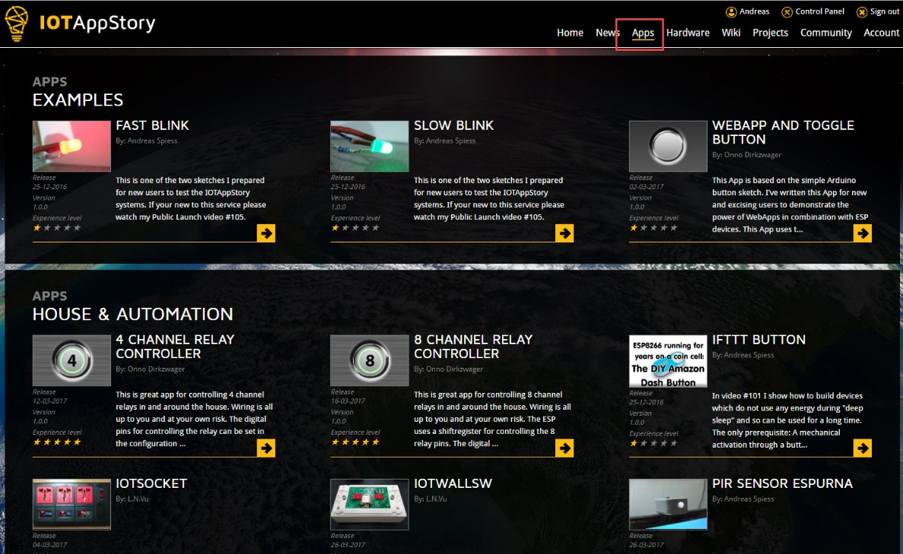

Here, you find a selection of APPS, arranged in topics like “Examples”. You can select your favorite, and add it to your selection by pressing ADD TO MY APPS:

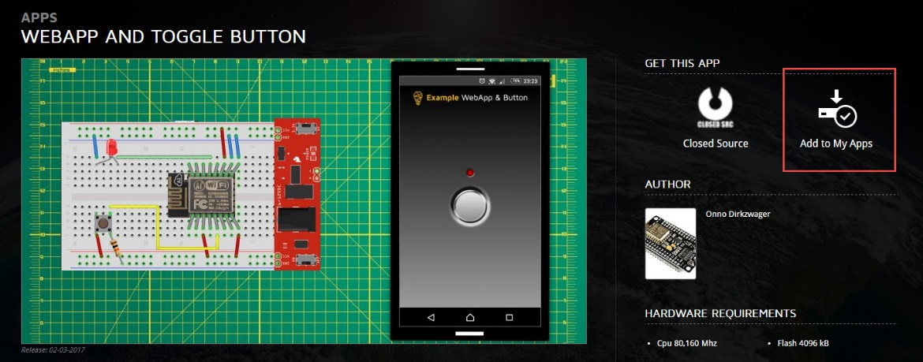

If you already have it in your APPS, it is marked:

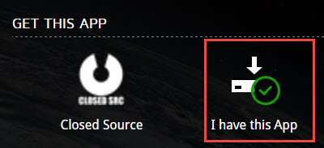

Now, you can go on to the next step.

## Register your devIce

Devices have to be added (registered) to IOTAppStory.com and later, added to a Project.

Go to Control Panel:

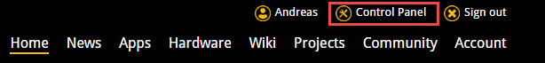

Here, you can go to Devices



Press +Add Device

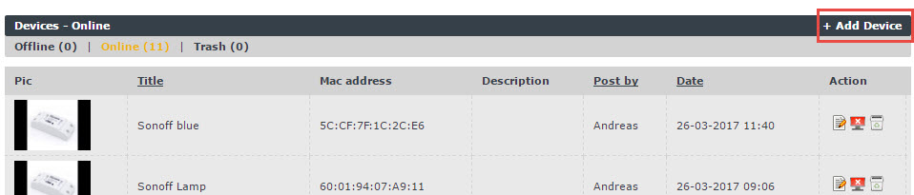

Now, you have to Name it and enter its MAC address. The MAC address is unique for each board. You get it, if you start the ESP_Loader Firmware on your Device (see How to get started.docx )

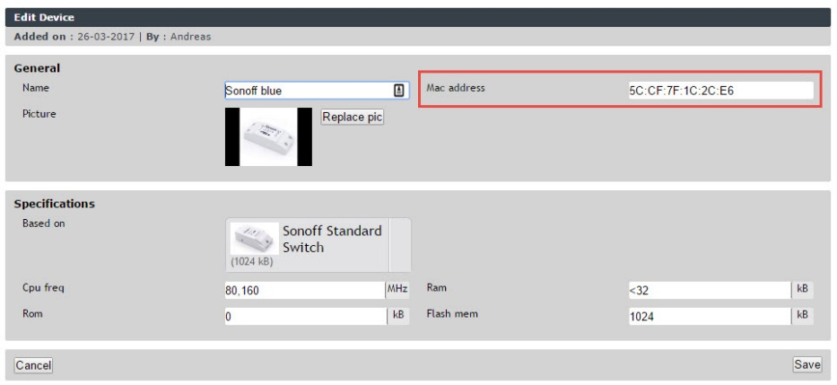

Select the Board Type your Device is based on and upload a picture for future ease of reference. A picture tells more than 1000 words…

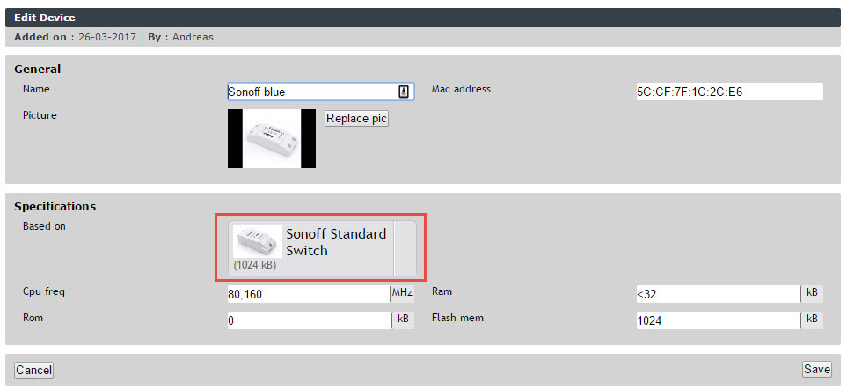

Your Device immediately will be online. If you want to hide it, you can set it offline, or, later on, also edit or delete it.

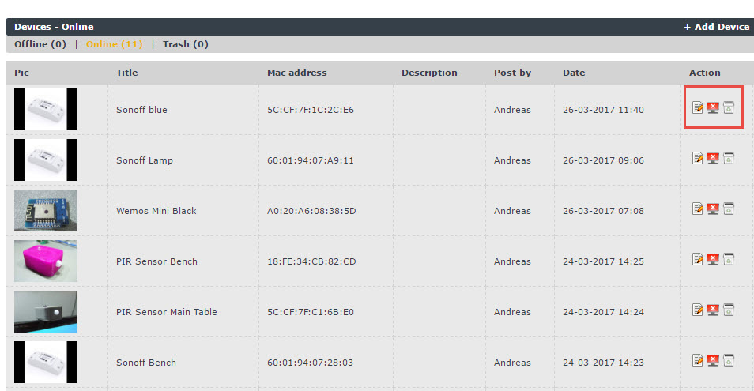

You only see your own Devices. Each Device only has to be created once and can be used again and again.

## Create a project

A Project is the combination of an APP and one or more Devices. All Devices in the Project get the same Firmware loaded over the air.

In control panel, go to Projects

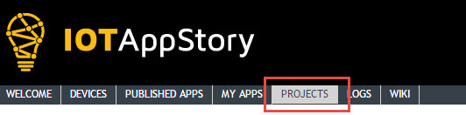

And add a Project:

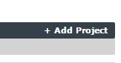

Here, again, name it and upload a nice picture:

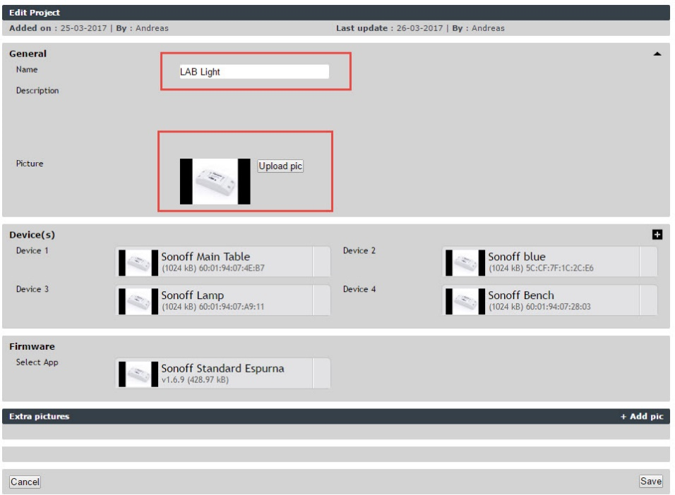

Next, you can add your Device or your Devices. Just press the Plus Sign:

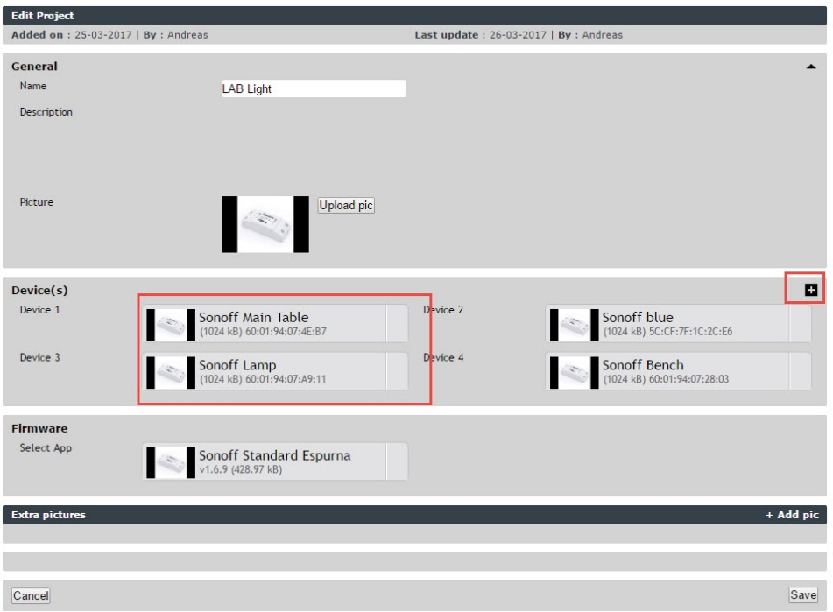

The next step is to add the Firmware. Here, you can select from your APPS. If you do not find your desired APP, you did not transfer it from the Official APPS